9. Telecommunicatiewet Compliance for Log360
Tagline – Ensure Telecommunicatiewet compliance with comprehensive telecommunications security monitoring using Log360.
Overview:
The Telecommunicatiewet Compliance extension for Log360 helps telecommunications organizations align with the Dutch Telecommunicatiewet requirements. By integrating this extension, IT and security teams gain deep visibility into their security posture and communication infrastructure controls.
Log360 continuously collects and correlates log data from Active Directory, Windows, Unix/Linux, Microsoft 365, cloud platforms, and network devices, mapping events directly to Telecommunicatiewet standards. Security teams can track compliance status in real time, investigate incidents quickly, and generate audit-ready reports with a single click.
Key Features:
- Generate comprehensive audit-reports mapped to all Telecommunicatiewet telecommunications security controls.
- Aggregates logs from various sources including servers, workstations, network devices, cloud platforms, and applications in real-time.
- Analyzes user and entity behavior for insider threats and unusual network communication patterns.
- Export reports in PDF and CSV format for auditors, management, or regulatory submissions.

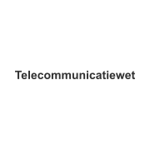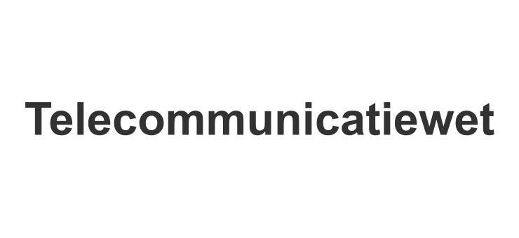
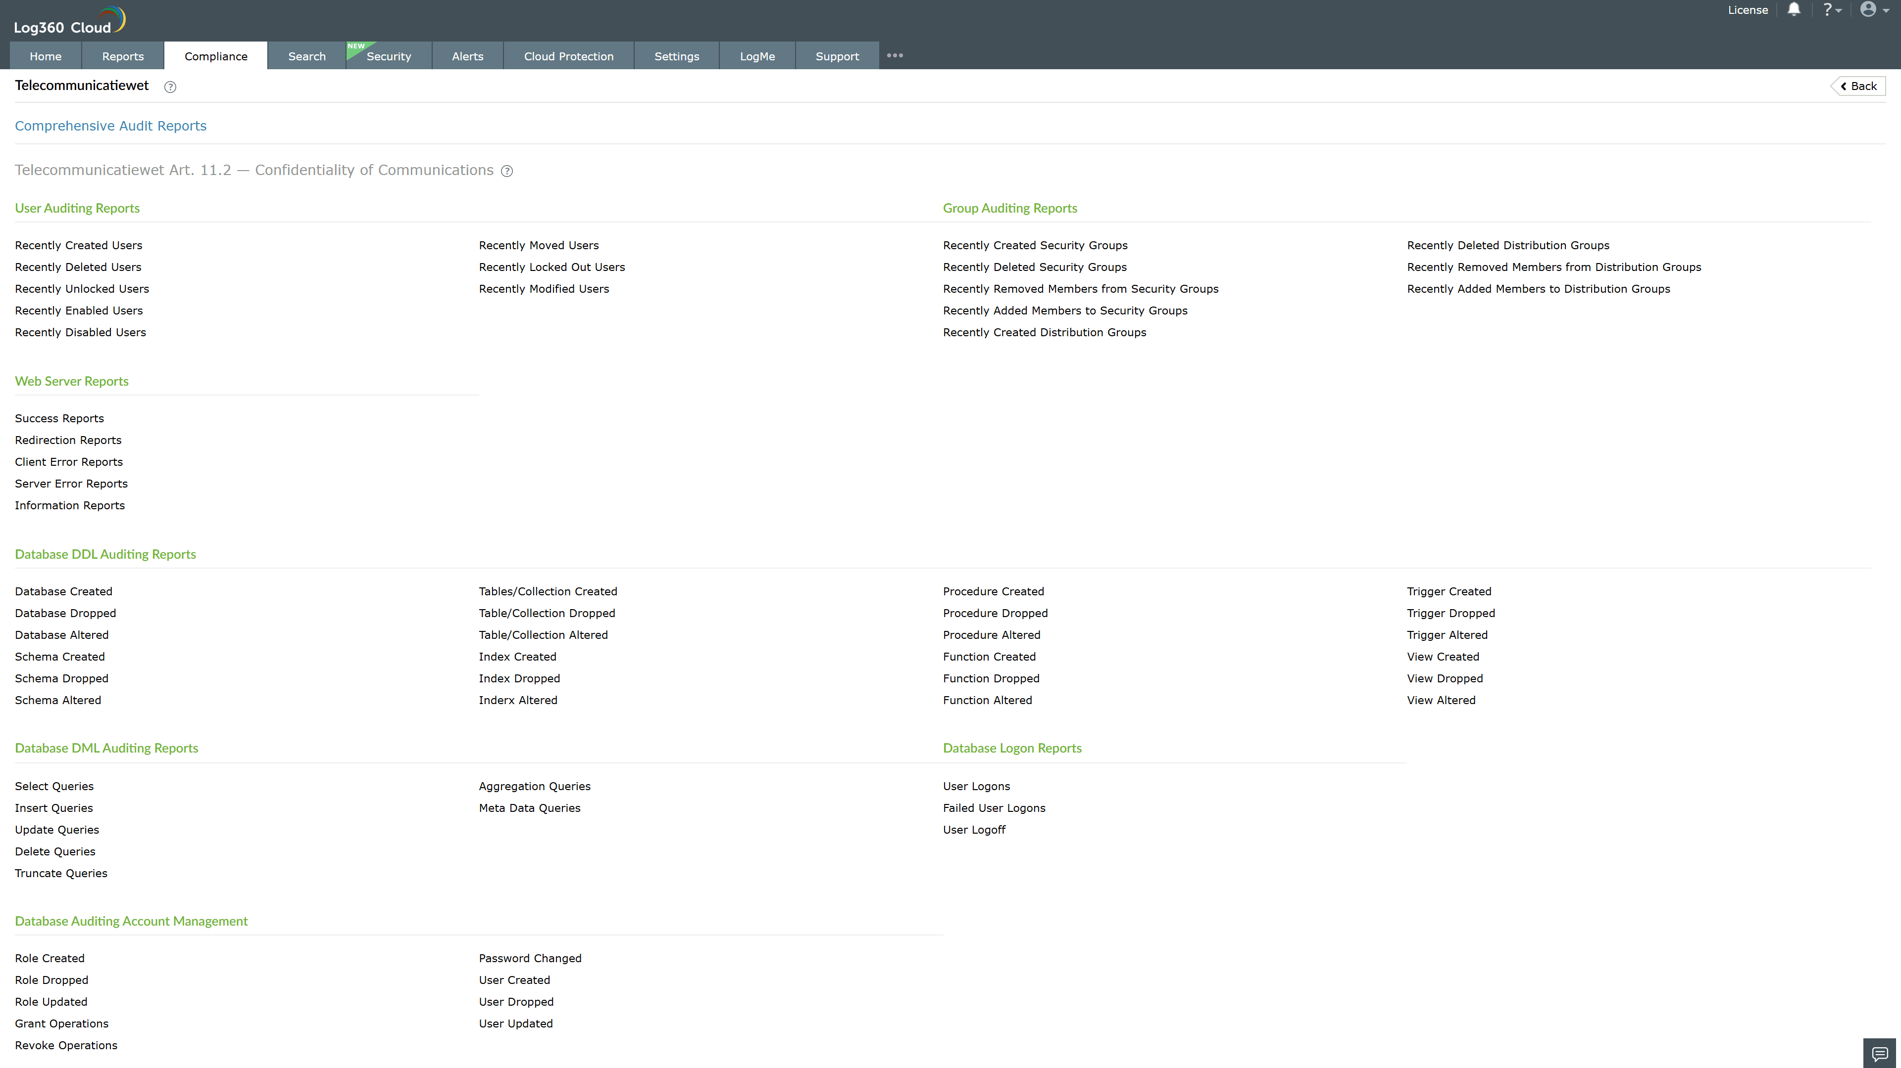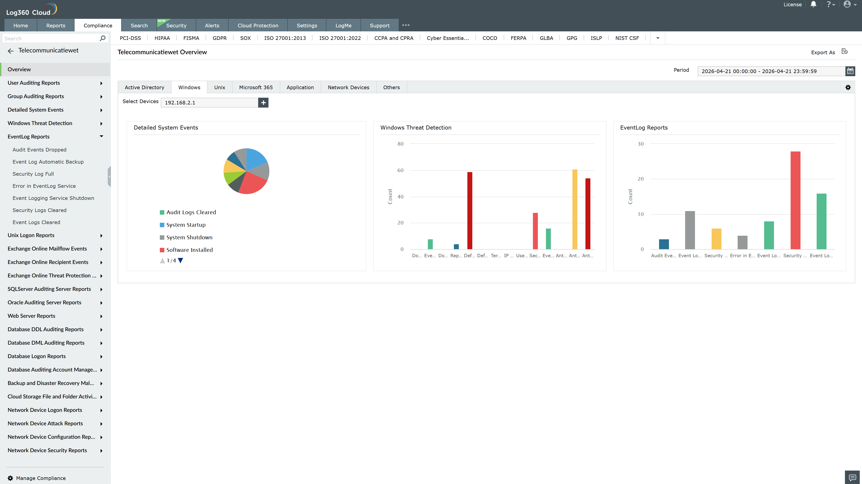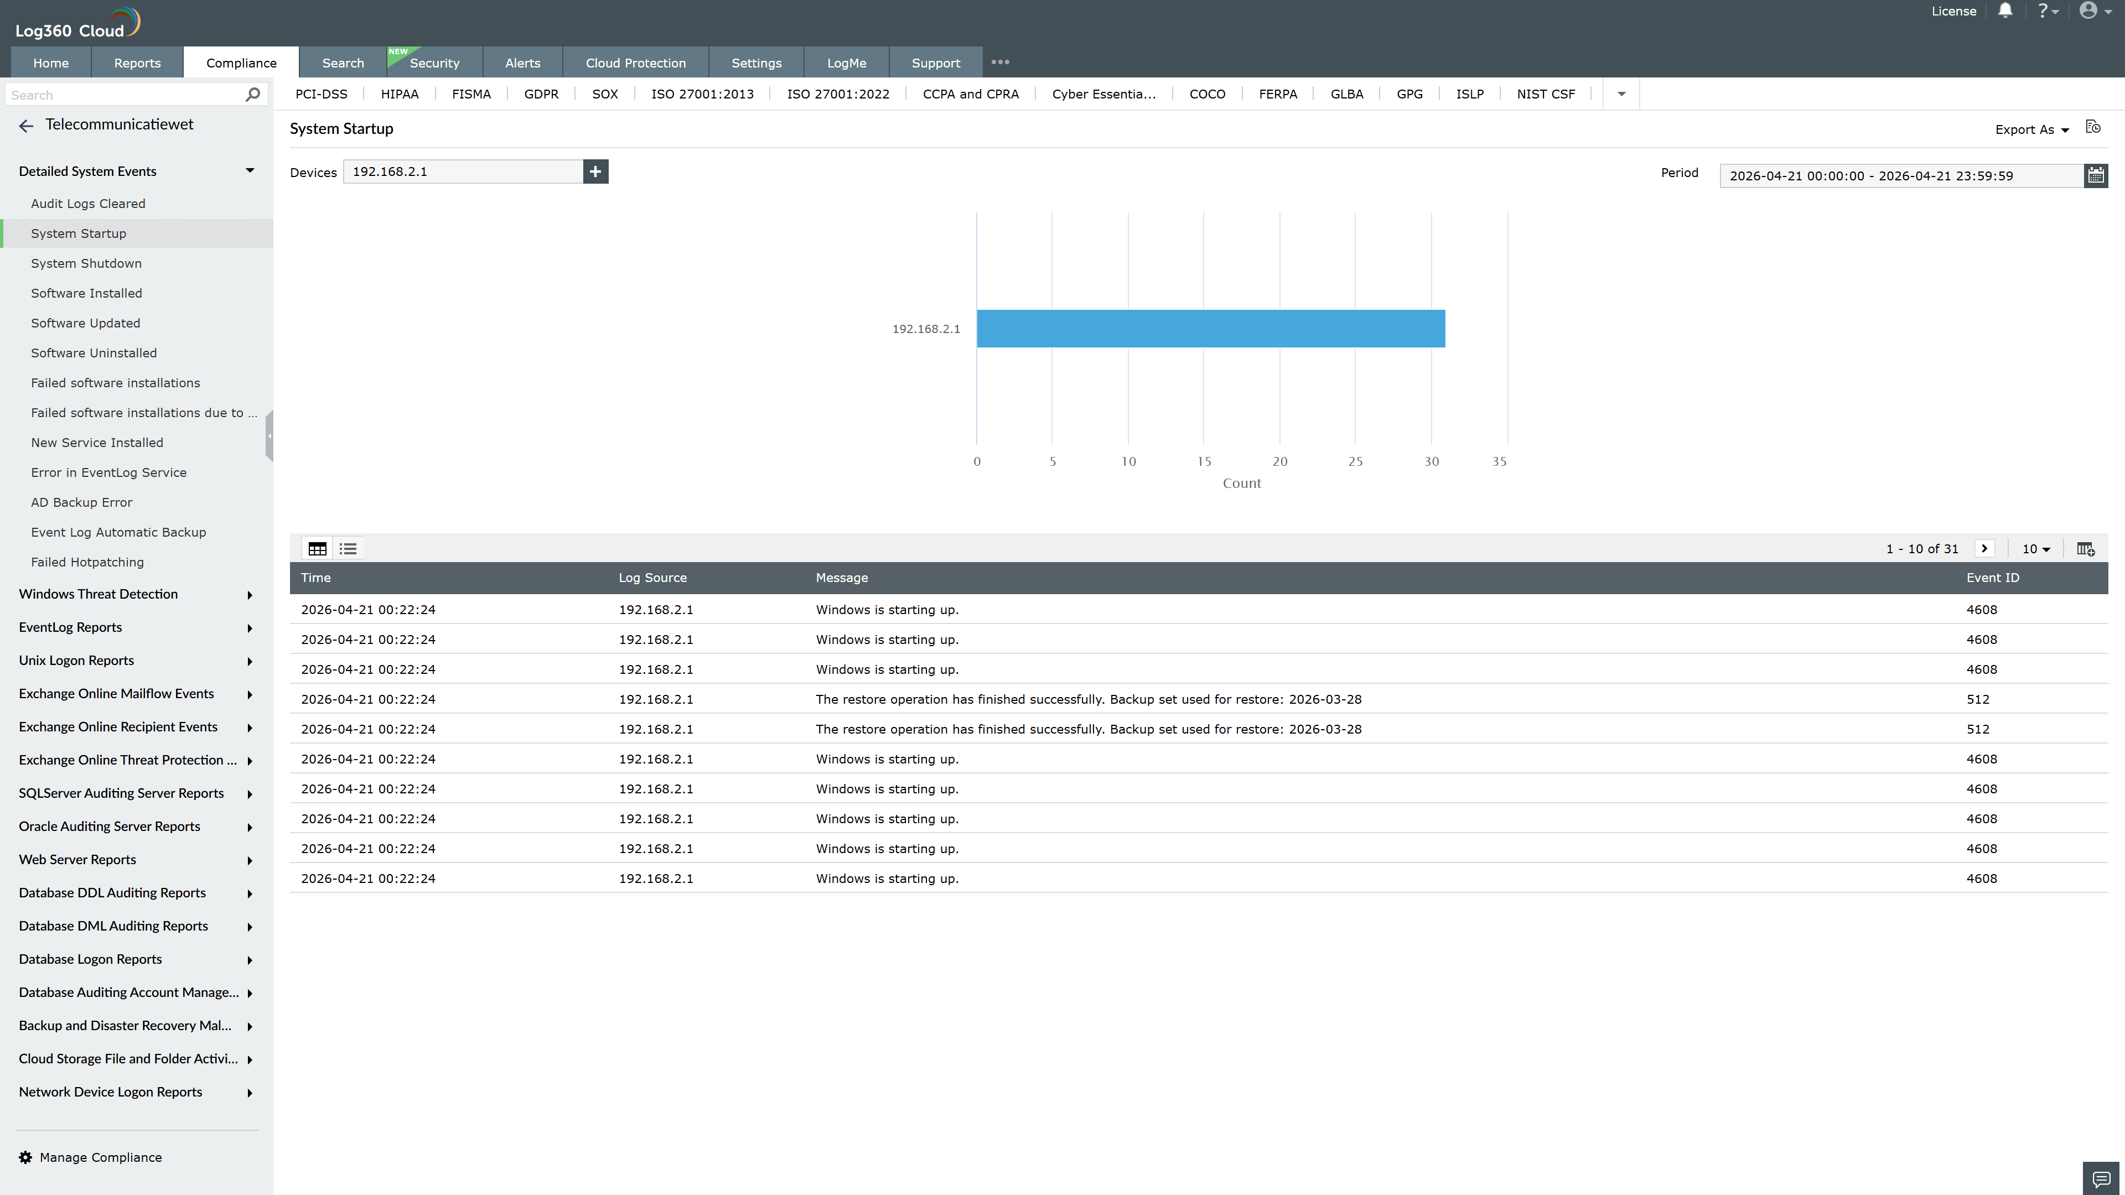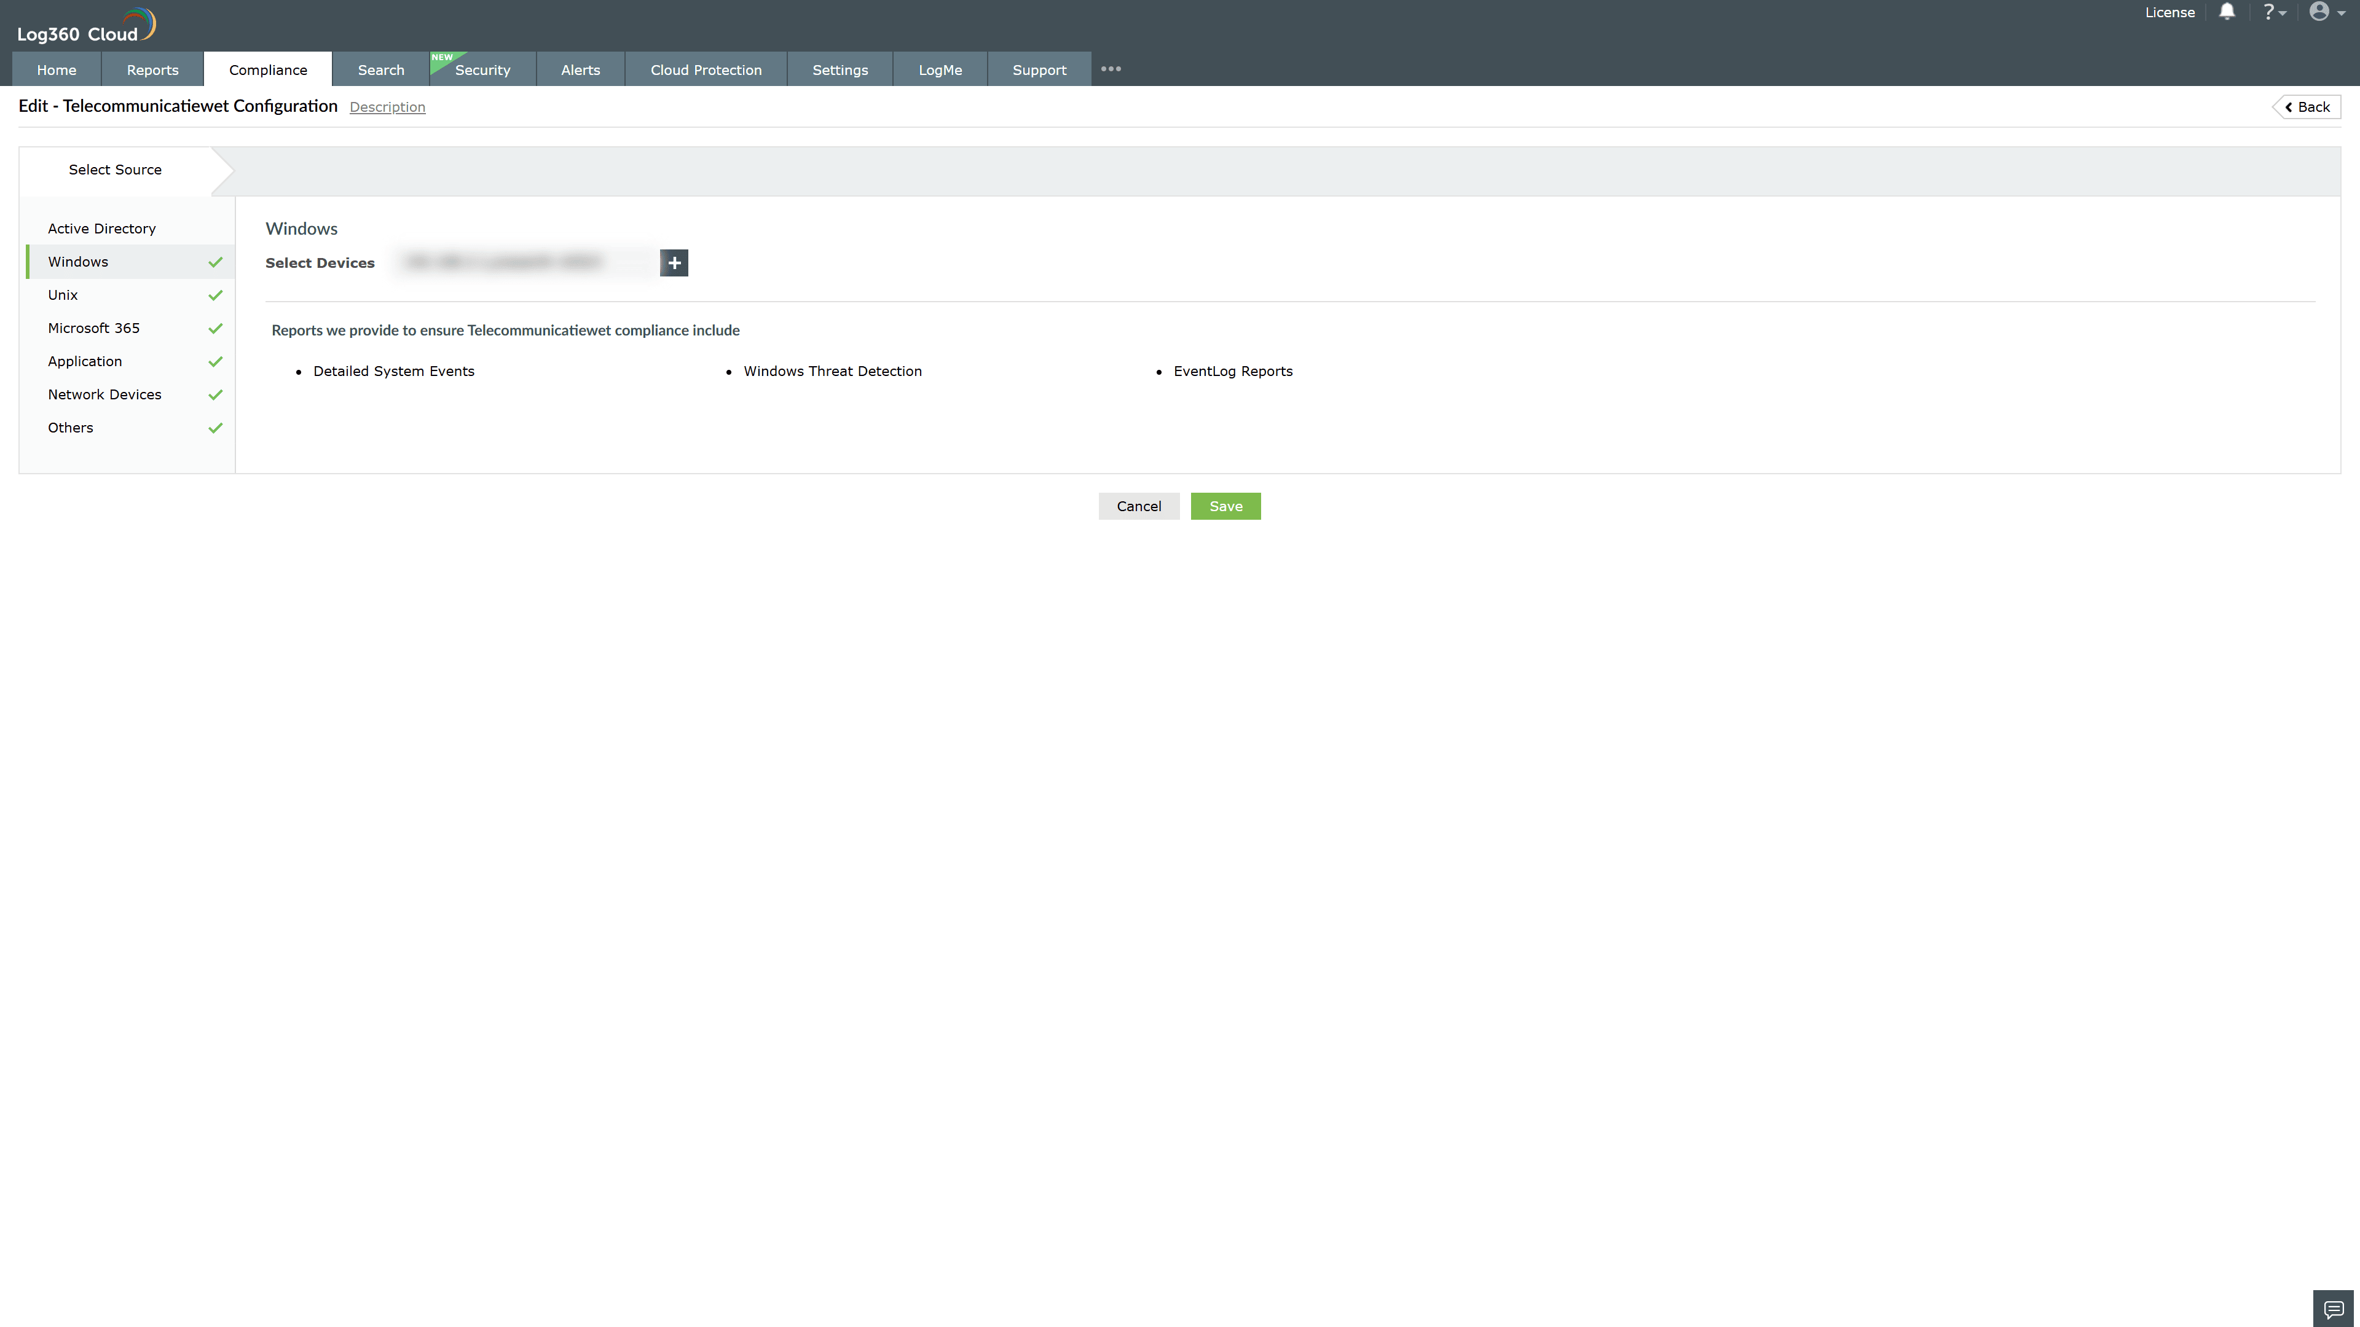

Valid Submission : Yes
Supported Editions : Free, Basic, Standard, Professional, MSSP
Help Document : https://www.manageengine.com/log-management/help/integrations/compliance-extensions.html
Help Video : Not provided
Tags : Log360, Compliance, Privacy monitoring, Data privacy, Regulatory compliance
Supported DCs : US, IN, JP, CA, AU, UK and EU
Privacy Policy:
Terms of Service:
Release Notes:
Predefined reports for the Telecommunicatiewet Compliance.

